Second Semester OOP Java Project



BY :

SHUITA MANDHAN

VANDNA JESWANI

AIRLINE RESERVATION SYSTEM

Airline Reservation System is software which is helpful for ticketing manager as well as the customers. In the later system all the activities were done manually. It was very time consuming and costly. An online airline reservation system allows customers to book their reservations via app.



Benefits of Airline Reservation System:

* Easy to book tickets
* Saves time and money
* Provides every information about flight
* Send automated tickets to the customer by mail
* Available for both Domestic and International Airlines

This airline reservation system can be used by the passenger to reserve a seat by choosing an reservation option and fulfilling its requirements. When the program will execute it shows you the menu page in which there are two modules (Reservation, Exit Program).

Reservation:

when the passenger clicks the reservation option the program will ask the passenger for its origin and destination the customer will have two choices to choose either an International airline or Domestic airline.

After choosing the airline when the passenger clicks the button proceed the program asks the passenger for flight scheduling, the passenger will have 3 schedules (morning, afternoon, evening).

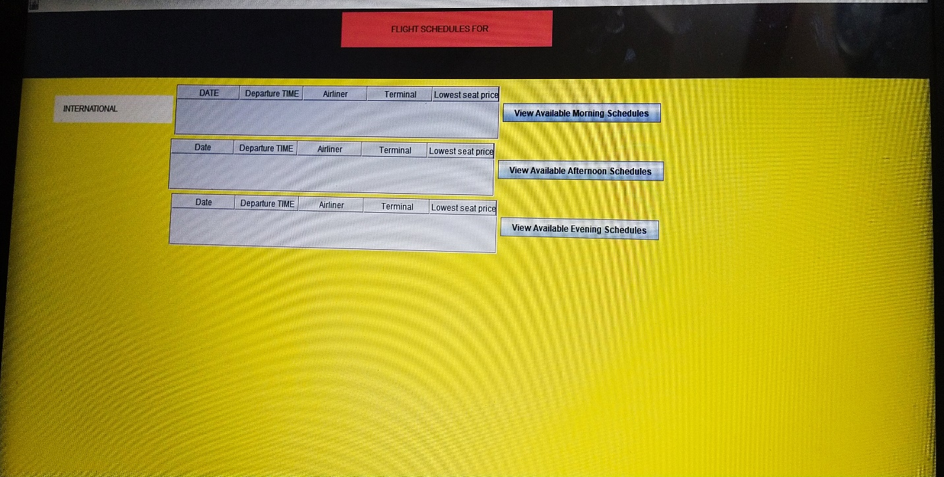

When passenger clicks any schedule he wants it will show him available flights whatever flight the passenger chooses then it will ask for the plane seats either Economy or First class seats whatever the passenger chooses

then in the end it will ask the passenger info(Name, Contact No).

then there is payment method which has three modules (Paypal card, Master card, Visa card).

And the passenger finally click the button purchase.

His ticket will be booked successfully.

Exit Program:

When the passenger clicked the exit program, the program will be exit successfully.

Libraries that are used:

* import javax.swing.\*;
* import java.awt.\*;
* import java.awt.event.ActionEvent;
* import java.awt.event.ActionListener;
* import java.awt.event.WindowEvent;
* import javax.swing.event.ListSelectionEvent;
* import javax.swing.event.ListSelectionListener;
* import javax.swing.table.DefaultTableModel;
* import javax.swing.table.TableColumn;
* import javax.swing.table.TableModel;